**SRE Project on Course mate Finder**

1. Introduction

This section gives a scope description and overview of everything included in this software. Also, the purpose for this document is described and a list of abbreviations and definitions is provided.

1.1 Purpose

The purpose of this document is to give a detailed description of the requirements for creating an android application 'Course Mate Finder' which is a course mate finding service system. It will illustrate the purpose and complete declaration for the development of system. It will also explain the purpose and features of the system, the constraints, interface and interactions with other external applications. This document is primarily intended to be proposed to a customer for its approval and a reference for developing the first version of the system for the development team.

1.2 Document Conventions

This document follows MLA Format. Bold-faced text has been used to emphasize section and sub-section headings. Highlighting is to point out words in the glossary and italicized text is used to label and recognize diagrams.

1.3 Intended Audience and Reading Suggestions

The intended audience for this document is the project sponsor, the development team and the team advisor. Throughout the rest of this document the project will be broken up into sections for: Project Description, System Features, External Interface Requirements, and Non-Functional Requirements. There is also a Glossary of common terms found throughout the document and some Analysis Models for this project.

1.4 Project Scope

This project 'course mate finder' is an online-based mobile application. Nowadays many private university has open credit system. So this phone application helps the students of private universities in Bangladesh to find their friends who are in same course. The application should be free to download from either mobile phone application store or similar services.

Users can provide their daily class course routine information to this application. This information will act as the bases for the desired results displayed to the user. This is the main goal of this project to give the information of other student’s class with same schedules to the user within few taps so that they can easily get what they are searching for. The benefit of this is that after getting the information they can communicate with the other user of same course with some internal communication services.

Furthermore, the software needs Internet connections to fetch and display results. All system information is maintained in a database, which is located on a web-server. Also for communication it has messaging service. The application also has the capability of representing other users’ daily schedules and profile information.

1.5 References

[1] IEEE Software Engineering Standards Committee, “IEEE Std 830-1998, IEEE Recommended Practice for Software Requirements Specifications”, October 20, 1998.

[2] Feldt R,”re_lecture5b_100914”, unpublished.

[3] Davis M A, “Just Enough Requirements Management: Where Software Development Meets Marketing”, New York, Dorset House Publishing, 2005.

[4] Karlsson J, “A Cost-Value Approach for Prioritizing Requirements”, Norges Teknisk Naturvitenskapelige Uni. 1997

**2. Overall Description**

This section will give an overview of the whole system. The system will be explained in its context to show how the system interacts with other systems and introduce the basic functionality of it. It will also describe what type of stakeholders that will use the system and what functionality is available for each type. At last, the constraints and assumptions for the system will be presented.

2.1 Product perspective

This system is a new and very user-friendly system. It is totally different from some other finding and searching service systems. User friendly and simplified system environment is the major concern for this system. It is not complicated or complex to understand.

This system will consist of three parts:

i. Mobile Application

ii. Database Server

iii. XMPP Server

Mobile Application: The mobile application will be used to get and modify information such as find and view information of other users. It will provide a nice and environmental user interface. This application will need to communicate with Messaging applications system. As well as it will communicate with Database server from where it will collect the information to the user interface and show to the user.

Database Server: Since this is a data-centric product it will need somewhere to store the data. For that, a database will be used. Mobile Application will communicate with database. It will use the database in two different ways one is for store data which is provided by the users and one is to get the data.

XMPP Server: As this product is going to provide messaging services it will need Extensible Messaging and Presence Protocol (XMPP). It enables the near-real-time exchange of structured yet extensible data between any two or more network entities. Therefore, two or more users can intercommunicate between themselves via messaging. Unlike most instant messaging protocols, XMPP is defined in an open standard and uses an open systems approach of development and application, by which anyone may implement an XMPP service and interoperate with other organizations' implementations.

2.2 Product Features

With the mobile application, the users will be able to see which of their friends or other users are available in their course. This feature is the major priority of this project.

After signing up and creating user profile the users will be accessed directly to the home feed. From here they will be able to see their course mate list with their current status according to the majority of the interactions. There is another interface which will show the daily class schedules of the same course mates.

For communications, there are two functionality which are messaging and direct phone calls. Also, one can send course mate request and can accept or remove course mate requests. All these will be notified in the notification interface. Details will be provided later on in the System Features section.

2.3 User Classes and Characteristics

There will be only one user class who is basically the user of this mobile application system. There are no other user classes exists in this system.

There are two types of users that interact with the system which are:

1. Student
2. Administrators

Each of these three types of users has different characteristics and use of the system so each of them has their own requirements.

Students are the main user of this application and this application is designed solely for serving their purpose. Students can log in with their academic ID and password and select among their already taken courses. Every course will have a separate group. By selecting courses, they are actually selecting in what groups they want to participate. Each group will show already existing students in the group. They can chat in the group, ask questions, get help, upload or download file. Students can even chat privately even both of them want. From this application, they can also connect with their friends’ social networks.

The administrators are only interacting with the web portal. They are managing the overall system so there is no incorrect information within it. The administrator can manage the information for both the phone application users.

2.4 Operating Environment

This system will only run both on Android and iOS operating system. Latest every version of Android and iOS can use this application. For better and efficient use and support we are omitting the older versions of both of this operating system.

For Android:

Applicable Operating System - Version

Jelly Bean - 4.1-4.3.1

KitKat - 4.4-4.4.4

Lollipop - 5.0-5.1.1

Marshmallow - 6.0-6.0.1

Nougat - 7.0-7.1

For iOS:

Applicable Operating System - Version

iOS9 - 9.3.5

iOS10 - 10.2.1

2.5 Design and Implementation Constraints

CO-1: Only any running Student of University, School or Colleges will be able to use the Application due to verification Process of administration.

CO-2: This Application will be firstly available for Android and later on IOS. Any android phone supporting Jellybean will be able to run the application.

CO-3: The database system of this application will be based on Oracle Database.

CO-4: This application will only available in English Language.

CO-5: The internet connection is also a constraint for the application. Since the application fetches data from the database over the internet, it is crucial that there is an internet connection for the application to function.

2.6 User Documentation

UD-1: The first time a new user accesses the system and on user demand the system shall provide an demo of the application, to allow users easily get into the application.

UD-2: The application will also provide a user-manual in it.

UD-3: There will be option to send any complain or suggestion about user experience for improving the application

2.7 Assumptions and Dependencies

DE-1: The application is online based as it will be connected to database for checking the course mates and checking their schedules.

DE-DE2: Sign Up of a user will depend on the administration panel of the application.

AS-1: This application will be available to user 24/7.

AS-2: It will be a social network for university students.

**3.System Features:**

This section will give an overview of every features in this system. All the functionalities and every single detail will be considered here.

* 1. **List of all features:**

**3.1.1 Sign up:**

**Description**: A student need to create account/sign up to get all the facilities. So, he must give user id & password as mandatory information and Facebook id, Gmail id, image etc. as optional information to create his account. A confirmation mail will send to his given Gmail id.

**Priority:** High

**Functional requirement:** System shall create a newaccount.

**3.1.2 Login:**

**Description:** Student can login or get access to the server using email and password or directly using Facebook, Google plus.

**Priority:** High

**Functional requirements:** System shall allow the student to use the account.

**3.1.3 Request password:**

**Description:** If a student forgets his/her password then the student will be able to request for a new password.

**Priority:** High

**Functional requirements:** System shall send a PIN number to student’s Gmail account for verification to access the user to their account.

**3.1.4 Select course:**

**Description:** After successful loginstudent needs to select specific course.

**Priority:** high

**Functional requirements:** System shall allow a student to select specific course.

3.1.5 Modify Profiles:

Description: Students will be able to modify their profiles whenever they want like if they want to edit any section or information.

Priority: Medium

Functional Requirements: System shall update the information if users modify any data of their profile.

3.1.6 Show History:

Description: Students will be able to see the history of their every single activity.

Priority: Medium

Functional Requirements: System shall show the history of user activities.

3.1.7 Leave Group:

Description: Students will able to leave any group whenever they want.

Priority: Medium

Functional Requirements: System shall let the student to leave group.

3.1.8 View Group Members:

Description: Anytime any students can view the list of group embers in any group.

Priority: Medium

Functional Requirements: System shall show the list of group members.

3.1.9 Report:

Description: Students will be able to report for a particular problem.

Priority: Medium

Functional Requirements: System shall take all the reports and submit to the administration panel.

3.1.10 Rate:

Description: Students can rate to another user.

Priority: Low

Functional Requirements: System shall store the ratings for review purpose.

3.1.11 Switch User:

Description: Users can switch to another type of user.

Priority: Medium

Functional Requirements: System shall allow the user to be another type of user or ask for registration again for further use.

3.1.12 Sign Out:

Description: Users will be able to sign out from the system.

Priority: Low

Functional Requirements: System shall let the user to sign out.

3.1.13 Auto Assign:

Description: After login, if student doesn’t add any course, he/she will be automatically assigned to every registered section’s group.

Priority: Medium

Functional Requirements: System shall assign the user to every course’s group.

3.1.14 Member Limit:

Description: After reaching 40-42, new students will not be allowed to join that group.

Priority: High

Functional Requirements: System shall automatically prevent any user to join the group after reaching 40-42.

3.1.15 Send Request

Description: If any student wants to individually communicate with another student, he/she need to send request. Without acceptation from the opposite side messages cannot be sent.

Priority: High

Functional Requirements: System shall prevent sending messages without accepting request.

3.1.16 Banned

Description: If any student breaks any rules of the group, other students can report him/her. Based on the report admin can ban that student.

Priority: Medium

Functional Requirements: System shall let the admin remove the student.

**3.2 User stories:**

|  |  |  |  |
| --- | --- | --- | --- |
| ID | Use Case | Actor | User story |
| 1 | login | User | As a user, I want to login with my VUES ID and password, so that I can use my registered section to enter those section’s group. |
| 2 | logout | User | As a user, I want to logout so that I can enter with another user id and password if I want. |
| 3 | Add course | User | As a user, I want to add the registered course to the system so that I can add myself to these course’s group. |
| 4 | Chat with group members | User | . As a user, I want to chat with my every section group members to know what happens in my class and also can take any help regarding course and share any files. |
| 5 | Search Friends | User | As a user, I want to search friends so that I can stay connected with them and can contact them in future. |
| 6 | Show Friend list | User | As a user, I want to see the online list to know which of my course mates are active now. |
| 7 | Use old data | User | As a user, I want to use my previous semesters information/file so that I can reuse them |
| 8 | Create Profile | User | As a user, I want to create my profile so that I can keep my others information such as Facebook id, Gmail id etc. with access privilege. |
| 9 | Edit profile | User | . As a user, I want to edit my profile so that I can change any of my information or also change the access privilege anytime. |
| 10 | Report/Block | User | As a user, I want to gain the access to block someone so that I can avoid them if I need. |
| 11 | Receive Notifications | User | As a user, I want to receive notification from system so that I would able to know if there is any message for me or any kind of change happens. |
| 12 | Create Sections | Admin | As an admin, I want to create sections in database so that users/students can take place to those section’s group chat. |
| 13 | Update Database | Admin | As an admin, I want to the power of update any information in the database according to then needs. |
| 14 | Monitoring | Admin | As an admin, I want to the access of monitoring every functionalities so that if there is any problem or violation occurs then I can handle it from admin panel. |

* 1. **Business Requirements:**

1. Due to open credit system, students are failed to stay connected with each other. So Main business demand or main business objective of this software system is to make united all students under a common platform. This is the initial business requirement which is needed to be fulfilled.
2. As the software will build for AIUB students so business profit is the vital issue from authority/admin perspective. After using this software if all the students are benefited and can stick with each other than many students will get admitted in the university near future and that will be a big business benefit for this software.
3. Main user of this software is neither authority nor admin but the students. So, their satisfaction is important. If they feel comfortable, can stay connect their course mate and can share their necessary files then business requirement is fulfilled from user perspective.

**4.External interface requirement:**

4.1 User Interface

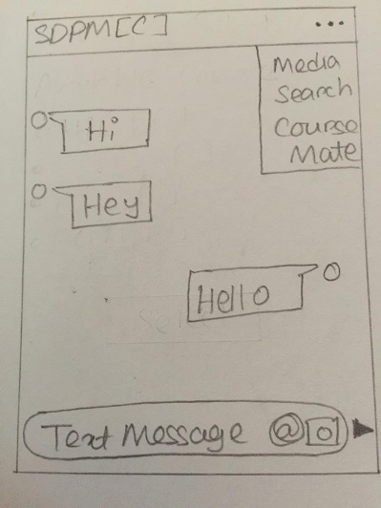 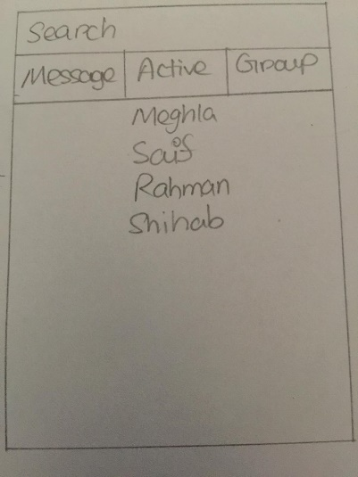 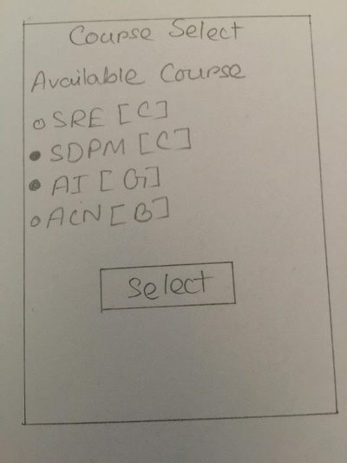

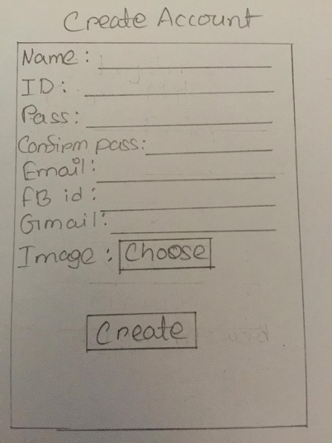 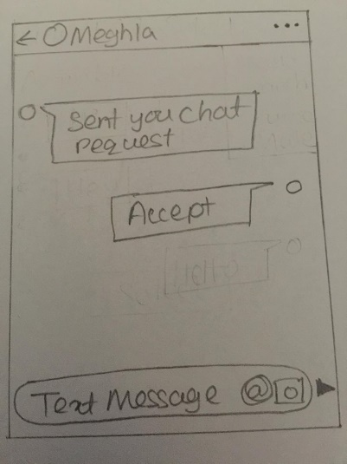 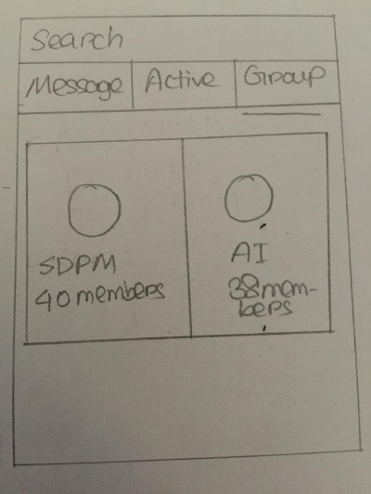

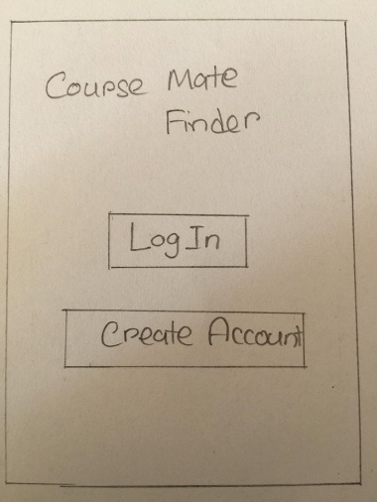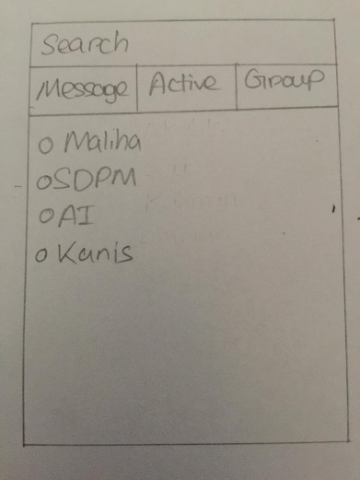

4.2 Hardware Interfaces

Since the mobile application has no designated hardware, it does not have any direct hardware interfaces. The camera access is needed to take photos, files can be shared from the phone, files can also be downloaded and stored and the hardware connection to the database server is managed by the underlying operating system on the mobile phone. Memory is used for storing purpose.

4.3 Software Interface

The mobile application need the camera access in order to capture photos and upload them. The mobile file system is needed to save the downloaded files and uploading them. It communicates with the database to collect relevant data and store data about each individual user and their related information. The communication between the database and the mobile application consists of operation concerning both reading and modifying the data.

4.4 Communication interfaces

The communication between the different parts of the system is important since they depend on each other. However, in what way the communication is achieved is not important for the system and is therefore handled by the underlying operating systems for the mobile application.

**5.Quality Attributes:**

**5.1 Usability:**

Establish requirements for effectiveness, efficiency and satisfaction for the user groups and tasks identified in the context of use analysis and in the scenarios.

Arrange a workshop attended by:

* user(s)
* developer(s).

A person and facilitator is needed to record the issues raised during the meeting.

* Review each of the tasks in the context analysis report along with their associated task [s](http://www.usabilitynet.org/trump/methods/recommended/scenarios.htm)cenarios to confirm their relevance and importance.
* Decide which task(s) and user type(s) needed usability criteria.

For each chosen task and user type estimate:

* the acceptable task time and the optimum target
* how to score effectiveness by agreeing what errors the user might make
* the effectiveness targets
* the satisfaction target.

* Usability should be evaluated in prototype field tests.

* 1. **Performance:**

Pe-1: The software needs to be responsive to the user.

Pe-2: Responses to queries shall take no longer then 5-6 seconds on backend.

Pe-3: Minimal time delay in sending and receiving data.

Pe-4: Server should be stress-tested to ensure full functionality during peak hours.

Pe-5: The software and servers need to be scaled accordingly.

Pe-6: Application may get a bit slow if many actions are performed by multiple users at the same time.

Pe-7: Primary Performance requirement of the application is speed of the Internet network of Mobile Phone.

Pe-8: The system will display the loading status of activity during action performed by the user.

**5.3 Security:**

1. All information's of a user data shall be encrypted and saved.

2. User will have to log in to application to perform any activity.

3. User will get the custom privacy experience.

4. Log in from multiple devices will not be possible. Users will only be able to use the application from a single device at a time.

**Cross-reference:**

* The system should be tested by separate non-technical persons to whether they like it or not.
* The system should take the shortest possible time to response

**6.Data requirements:**

**6.1 Logical data model [UML Diagrams]:**

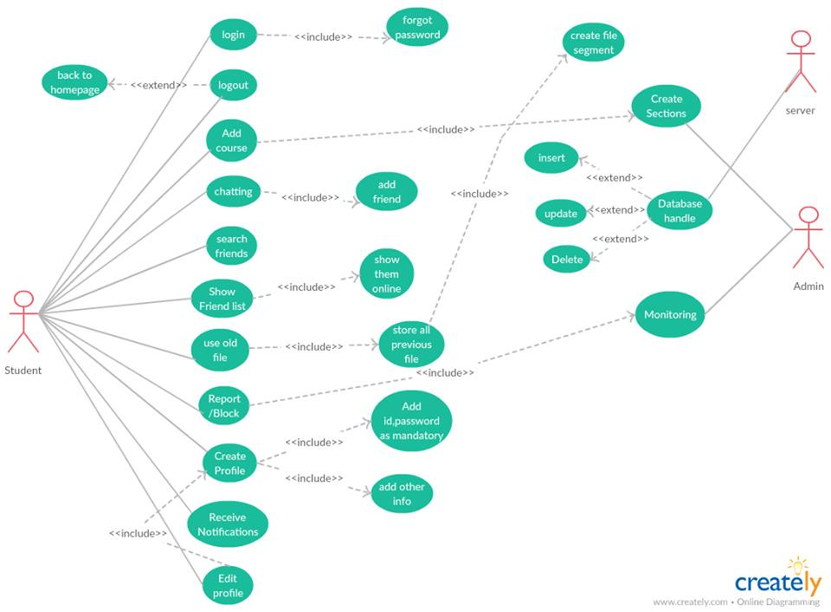

**Fig: use case diagram**

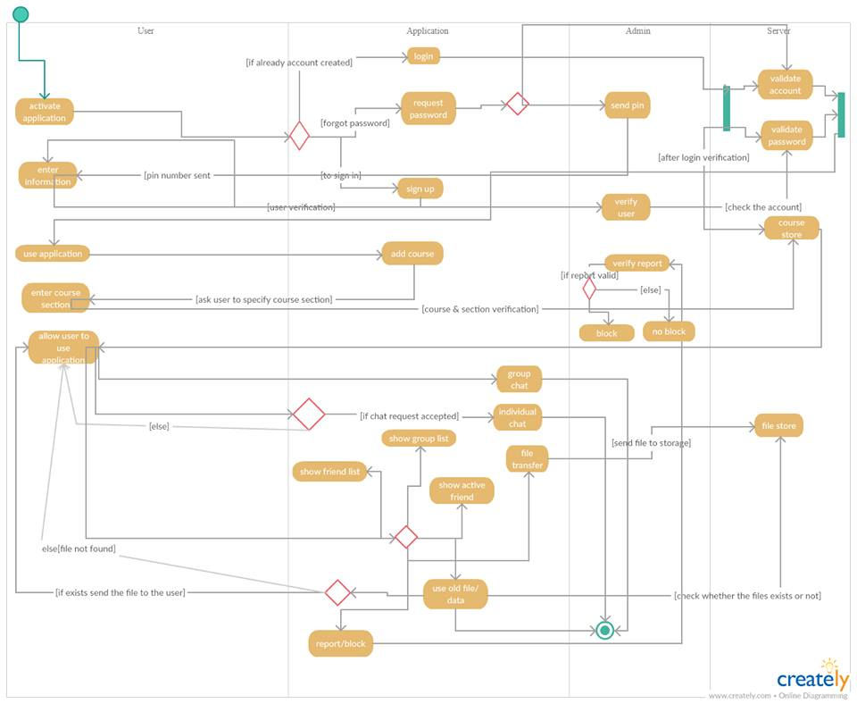

**Fig: activity diagram**

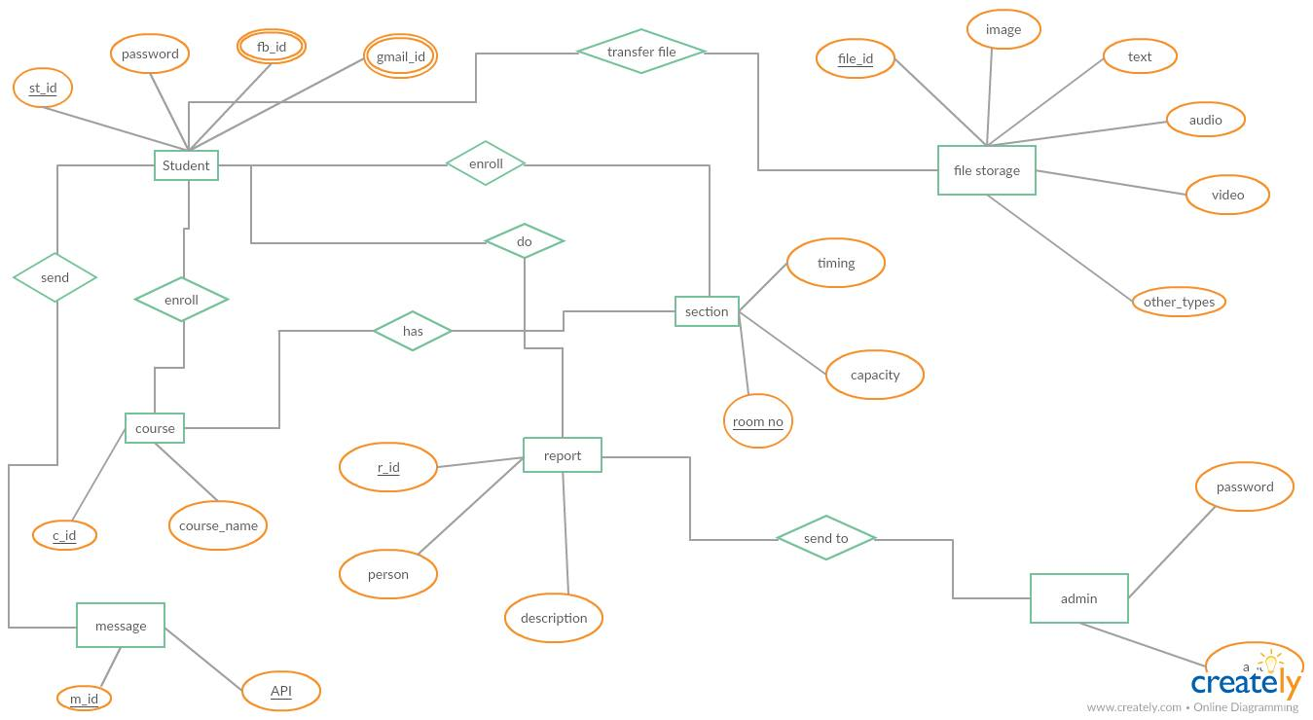

**Fig: ER Diagram**

**6.2 Data Dictionary:** Data Dictionary will describe the contents, format and structure of a database and the relationship between its elements, used to control access to and manipulation of the database. Data dictionary of the ER diagram is given below:

|  |  |  |  |  |
| --- | --- | --- | --- | --- |
| Entity | Attribute | Type/Size | Validation | Key |
| Student | St_id | String (10) | Required  (XX-XXXXX-X) | Primary |
| Student | password | number | Required |  |
| Student | Fb_id | String (40) | Optional |  |
| Student | Gmail_id | String (25) | Optional |  |
| Course | C_id | String (10) | Required | Primary |
| Course | Course_name | String (40) | Required |  |
| File storage | F_id | String (5) | Required | Primary |
| File storage | image | String (15) | Optional |  |
| File storage | text | String (1000) | Optional |  |
| File storage | audio | String (30) | Optional |  |
| File storage | video | String (30) | Optional |  |
| File storage | Other_types | String | Optional |  |
| Admin | A_id | String (8) | Required | Primary |
| Admin | Password | String (16) | Required |  |
| Report | R_id | Int (5) | Required | Primary |
| Report | person | String (15) | Required |  |
| Report | Description | String (100) | Optional |  |
| Section | Sec_id | String (7) | Required | Primary |
| Section | Timing | Time (10) | Required |  |
| Section | Room_no | Int (5) | Required |  |
| Section | Capacity | Int (2) | Required |  |

**6. Acknowledgements**

**Firstly we want to thank our course teacher MOHAMMAD MAHMUDUL HASAN sir for his huge support for our project. The total guidance of him lead us to a very successful project.**

**References**

**Hasan, M.M. (2015). E-Government Service Research Development: A Literature Review. International Journal of E-Services and Mobile Applications,volume 7, issue 1, page 22-49.**

**Hasan, M.M., Loucopoulos, M. and Nikolaidou, M. (2014). Classification and qualitative analysis of non-functional requirements approaches. In Enterprise, Business-Process and Information Systems Modeling. Thessaloniki, Greece, page 348-362.**

**CHR – Citizens Help Request (2012). Available at http://chr.police.gov.bd, Retrieved on May 29, 2012.**